Alexander Baldree
08/11/26
Module 1.1 Discussion Board
CSD440

I installed XAMPP on my MacBook, and the installation process went pretty smoothly (After checking the permissions in settings). XAMPP is a local web development environment that gives me several tools in one package, including Apache, MySQL/MariaDB, PHP, and phpMyAdmin. Instead of needing to install and configure each of these programs separately, XAMPP puts everything together so I can run and test websites directly from my own computer. This is helpful because I can work on PHP and database projects locally without needing to upload everything to an actual web server every time I want to test something.

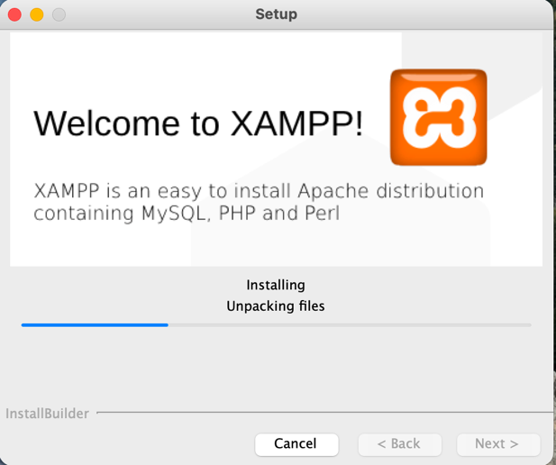
When I installed XAMPP on my MacBook, I first downloaded the macOS version and went through the installation process. Once it was installed, I opened the XAMPP manager and was able to start the Apache web server and the MySQL database service. After starting the services, I opened my web browser and went to localhost to make sure Apache was working correctly. Seeing the XAMPP page load in my browser confirmed that the local web server was running.
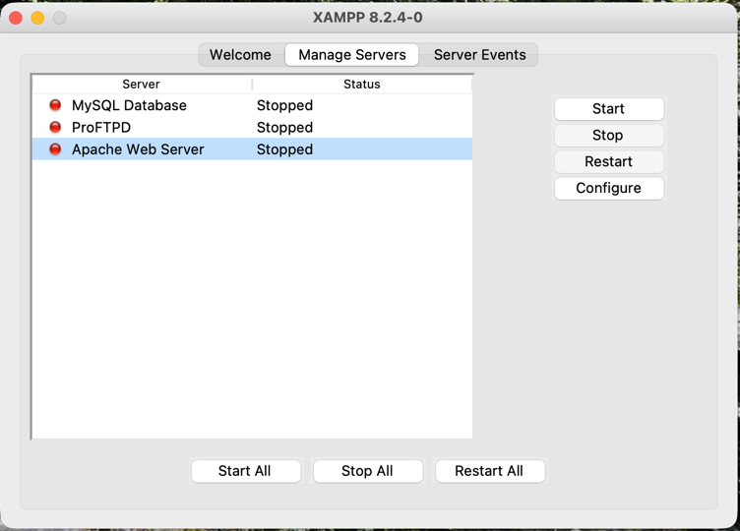
One thing I learned from installing XAMPP on a Mac is that it is important to pay attention to macOS security permissions. Since XAMPP installs software that runs local server services, macOS may ask for permission before allowing certain parts of the program to run. I also learned that if localhost does not load, one of the first things I should check is whether Apache is actually running. The same thing applies to MySQL if I am having trouble accessing a database or phpMyAdmin.
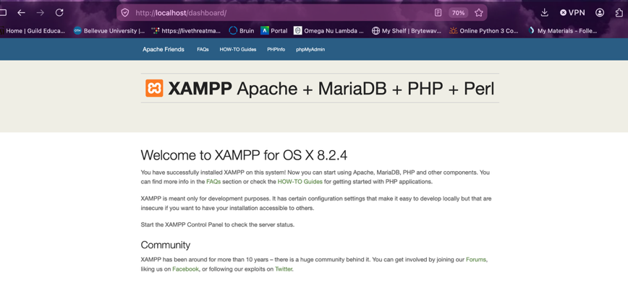
Installing XAMPP is relevant to what we are doing because it gives me a complete environment where I can practice working with PHP, databases, and web pages without affecting a live website. It also makes troubleshooting easier because I can make changes, refresh the browser, and immediately see if my code works.
Using XAMPP is a good way to learn server-side development because it allows me to see how the different parts of a web application connect together. My biggest recommendation for anyone having problems would be to first check that Apache and MySQL are running, make sure another application is not already using the same ports, and check the Mac security settings if XAMPP is being blocked from opening or running correctly.

References:
XAMPP- Module 1 Instructional Video

